Set up Delphi for e.LORS

1. Open the Command Prompt as an Administrator.
2. In the Command Prompt, type:

**REGSVR32.EXE "C:\Program Files (x86)\Common Files\Borland Shared\Debugger\BORdbk70.dll"**

1. From Z:\Delphi:
   * Extract **Imports.zip** to **C:\Program Files (x86)\Borland\Delphi7\Imports**.
   * Extract **Bpl.zip** to **C:\Program Files (x86)\Borland\Delphi7\Projects\Bpl**.
2. Click **Yes** if asked to replace files.
3. In RTC, load repository workspaces from the following project areas:

* DMT
* eLORS
* OLMS_Common_Delphi

**Note:** Projects are preconfigured with relative search paths assuming all folders are in the same workspace. If your projects are in different locations, you must replace the search paths with the correct locations.

1. Open Delphi as administrator
2. Open **Common_Delphi\ip3000vcl6\package\ip3000v6.dpk**.

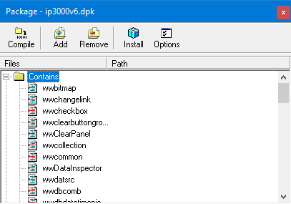

1. Click **Compile** and then **Install**.
2. Close the package.
3. Open **Common_Delphi\Components\OlmsPkg_DB2.dpk**.

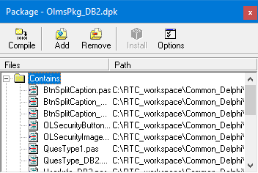

1. Click **Compile** and then **Install**.
2. Close the package.
3. Open **Common_Delphi\Components\OlmsPkg.dpk**.  
     
   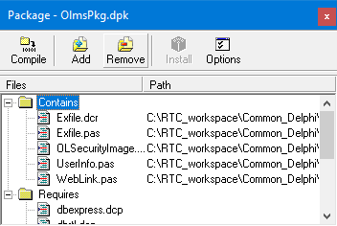
4. Click **Compile** and then **Install**.
5. Close the package.
6. Select **Component** > **Install Packages**.  
     
   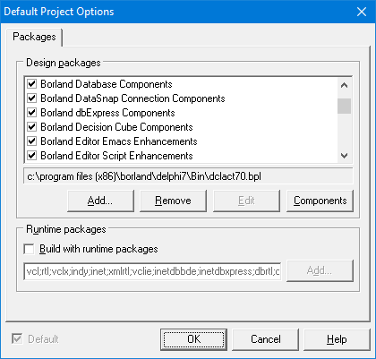
7. Click **Add**.
8. Go to **Common_Delphi\RBuilder\Lib\** and select the 4 .bpl files.  
     
   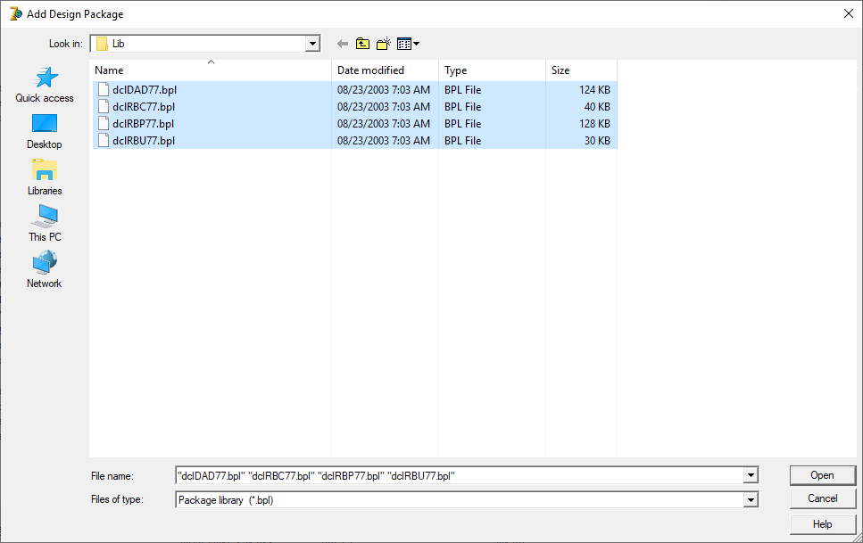
9. Click **Open**.
10. Click **Add** again.
11. Go to **Common_Delphi\Components\ESALoginD7** and select the esaLoginD7.bpl file.  
      
    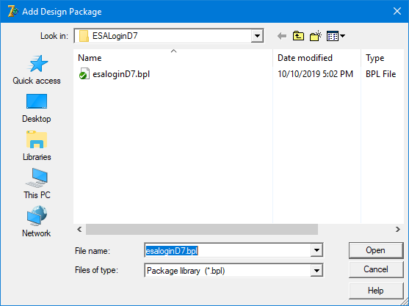
12. Click **Open**.
13. Click **OK** to close the window.
14. Open **eLORS\eLorsMain.dpr**.
15. Select **Project > Options > Directories/Conditionals**.  
      
    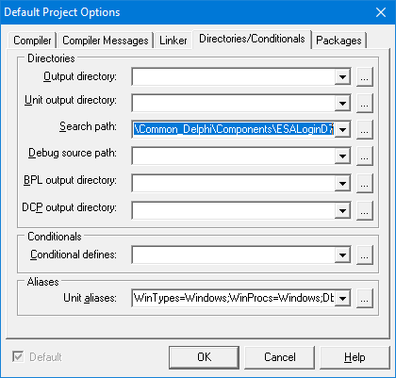
16. Click the ellipses button (**…**) next to the **Search path** field.
17. If any of the following search paths are greyed, replace them with the correct workspace location on your local machine:
    * **Common_Delphi\Components**
    * **Common_Delphi\Encryption_Software\Ciphers**
    * **Common_Delphi\Encryption_Software**
    * **Common_Delphi\Encryption_Software\Hashes**
    * **Common_Delphi\Components\OISecurity**
    * **Common_Delphi\Components\ChangeAddr**
    * **Common_Delphi\Components\ESALoginD7**
    * **Common_Delphi\RBuilder\Lib**

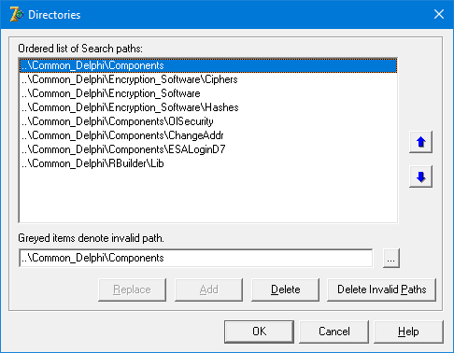

1. Click **OK**.
2. Select **Project > Build eLorsMain**.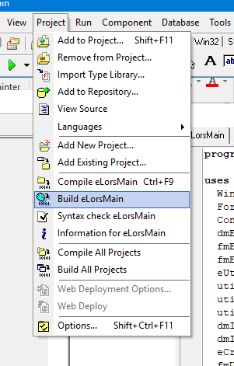
3. Verify that the build completes with no errors.
4. Select **Run > Run**.  
   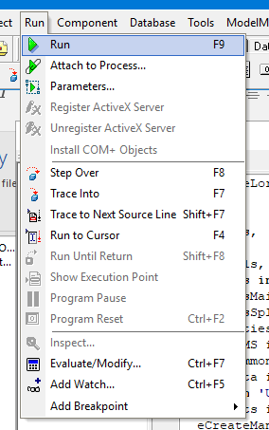
5. Verify that e.LORS runs successfully.
6. Click on Projects -> Options-> Compiler -> Debugging and check to start debug mode.

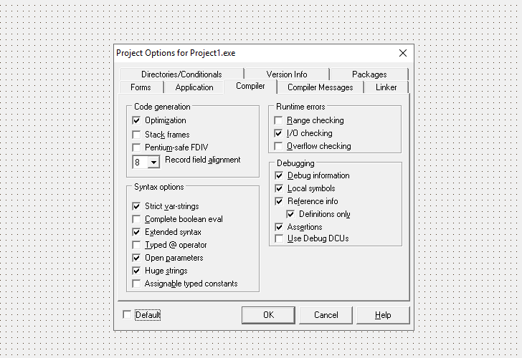

Shortcuts in debug mode

|  |  |
| --- | --- |
| **Debugging** | |
| F7 | Trace Into |
| F8 | Step Over |
| Shft-F7 | Trace to next source line |
| **Compiling** | |
| F5 | Compile Project |
| Ctrl-F5 | Build |
| F5 | Syntax Check |
| Ctrl-Shft-F11 | Project Options |
|  |  |
| **Debugger Windows** | |
| Ctrl-Alt-V | Event Log |
| Ctrl-Alt-B | Breakpoints |
| Ctrl-Alt-V | Watches |
| Ctrl-Alt-T | Threads |